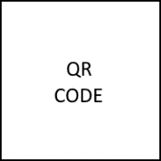Invoice number:

**XABFC-123456**